The Mill Restaurant
Figart, Dunfanaghy
Tel: 074 9136985
www.themillrestaurant.com
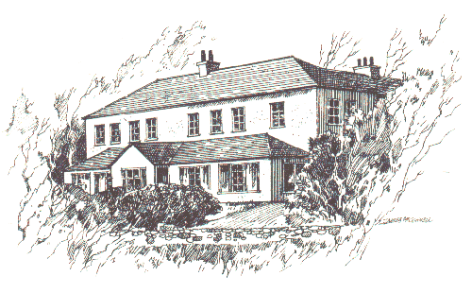
To Begin
Duck Liver
Pan Fried Duck Livers, Liver Parfait, black pudding, port oranges, parmesan puff croute and redcurrant.
Chicken Wings
Thyme glazed Chicken Wings, crisp pancetta, leek canneloni, wild mushrooms
Bar-B-Que sauce.
Organic Hen’s Egg
Herb crusted soft Organic Egg with glazed mixed Mushroom, crispy Tarragon and Bearnaise sauce.
Seafood Ravioli
Ravioli of scallop with Horn Head Lobster and a Crab sweetcorn Veloute with basil.
Terrine
Pressed terrine of Pork cheeks, smoked ham hocks and leeks, pear puree and baby
organic leaves.
Horn Head Kid Goat
Roast slow cooked Cleggan kid goat with sauté new potatoes, smoked bacon and red onion marmalade.

Something Refreshing
Armagh apple sorbet.

To Follow

Greencastle Monkfish
Spiced Greencastle Monkfish in brown butter, split pea and cumin, spring vegetables and cardamom yogurt.
Killybegs Turbot
Grilled Killybegs Turbot with peas and lettuce, crisp potatoes and tartare sauce.
Donegal Beef
Grilled Donegal Rib eye with oxtail croquette, roast garlic puree, Anna potatoes and leeks.
Horn Head Spring Lamb
Roast Horn Head Lamb with dauphinoise potatoes, spinach and basil, thyme and red wine sauce.
Goats Cheese Tart
Goats cheese and red pepper tart with mushroom duxelle baked shallots, sweet and sour vegetables.

Add an Extra €3
Crispy fat chips, Organic leaf salad with balsamic dressing, Stir fried greens

Kitchen Team
Derek Alcorn , Billie Mc Quaid, Marion Mc Grenra, Ben Alcorn, Tara Ferry

Our Suppliers
Stephen Kerr (butchers) Albatros (seafood), An Lan Teo, Killult (Organic Vegetables )Richard Alcorn (Horn Head Goat), Thomas Alcorn (Lamb) Ivan McElhinney (shellfish)

Dinner Menu €41

